Assignment Solutions –

**PART A :** When interaction only between Residue pairs A – A, B – B, C – C, D – D of different proteins is considered –Assemblies observed are shown below for different interaction energies of -1, -2, -3, -5 unit.

When IE = -1, Iteration = 1: (IE = Interaction Energy)

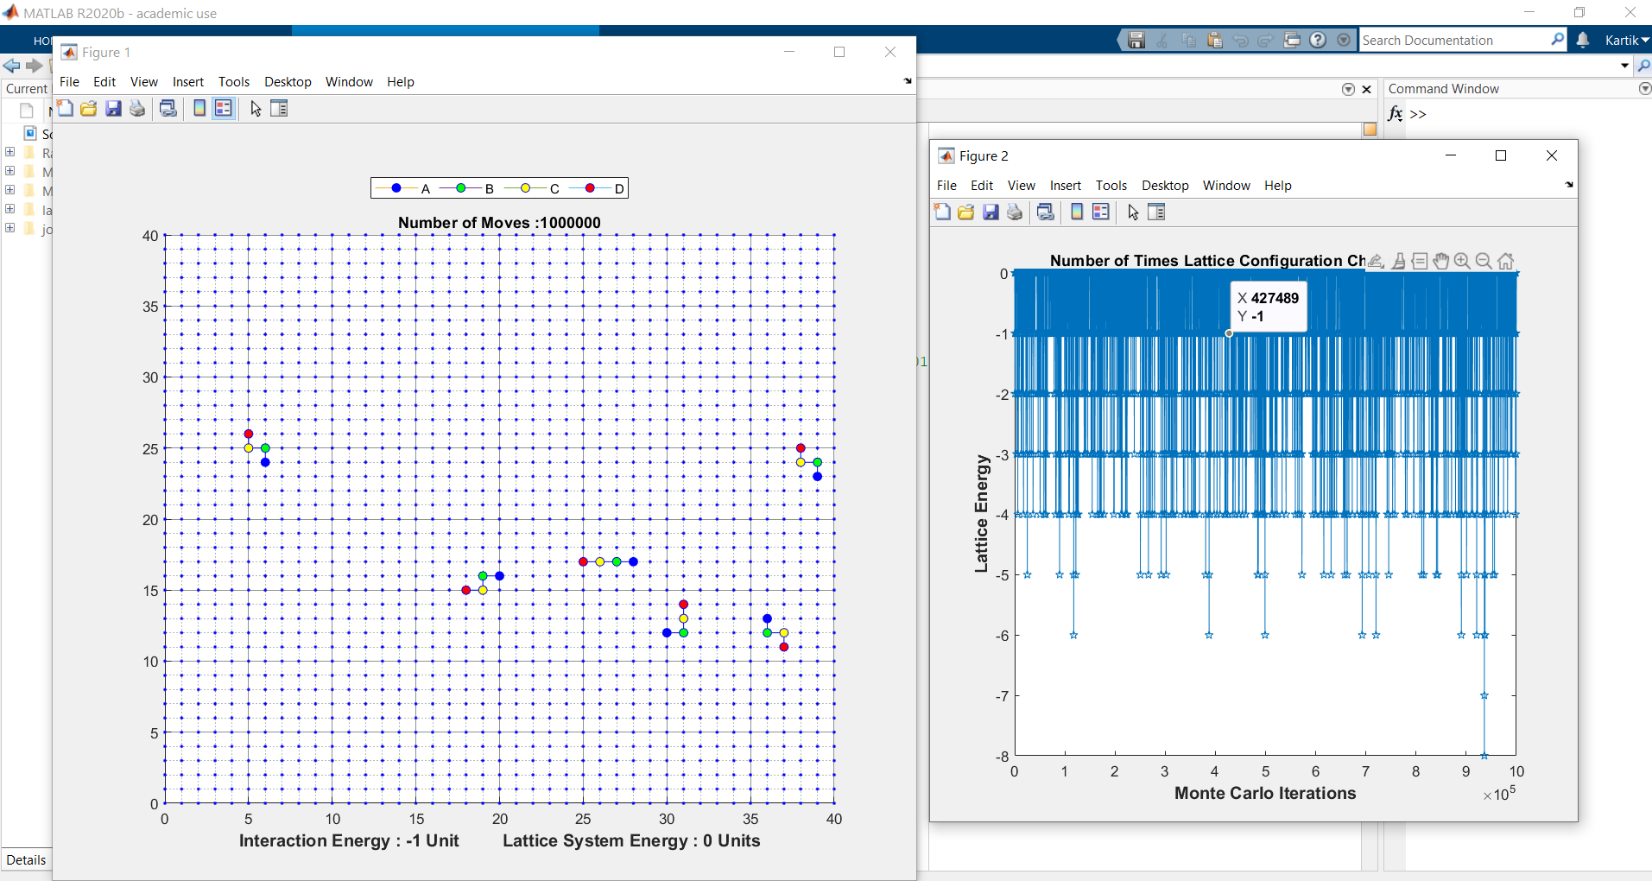

Iteration = 2:

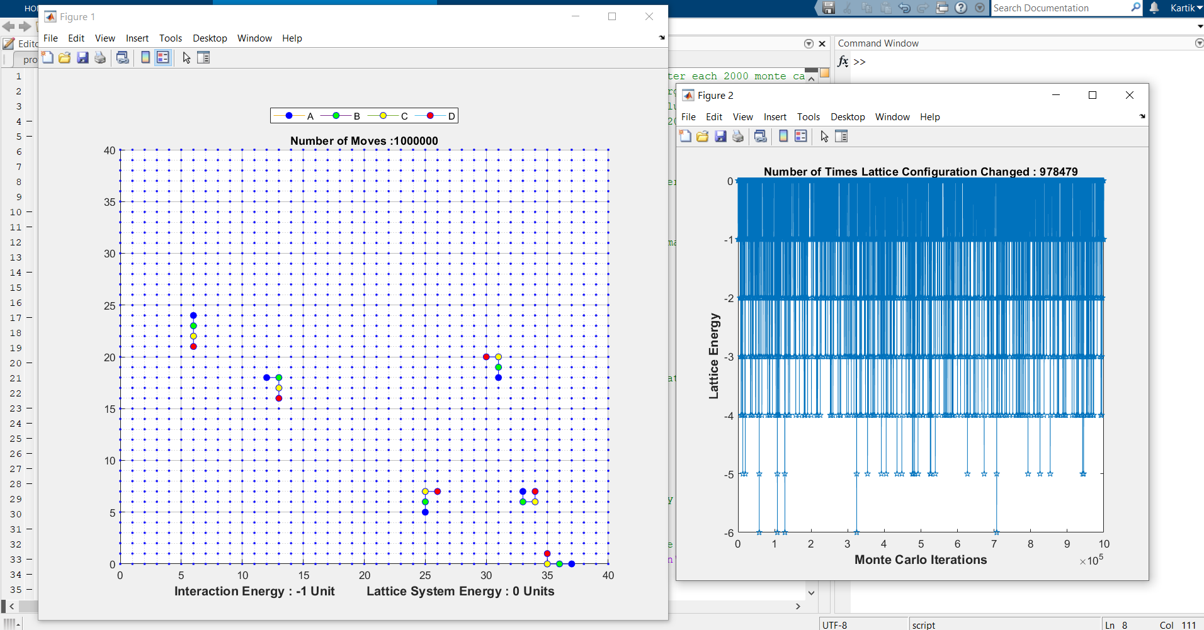

When Interaction Energy = -2, Iteration = 1

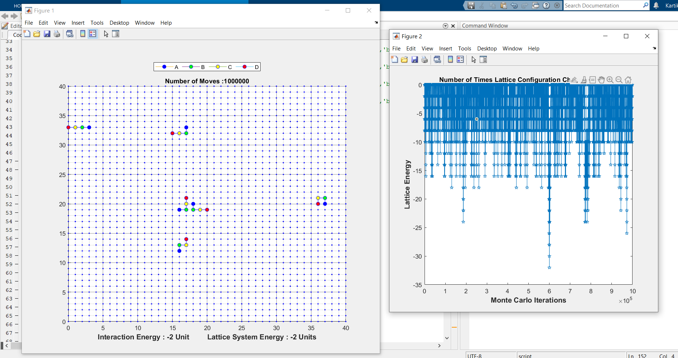

Iteration = 2

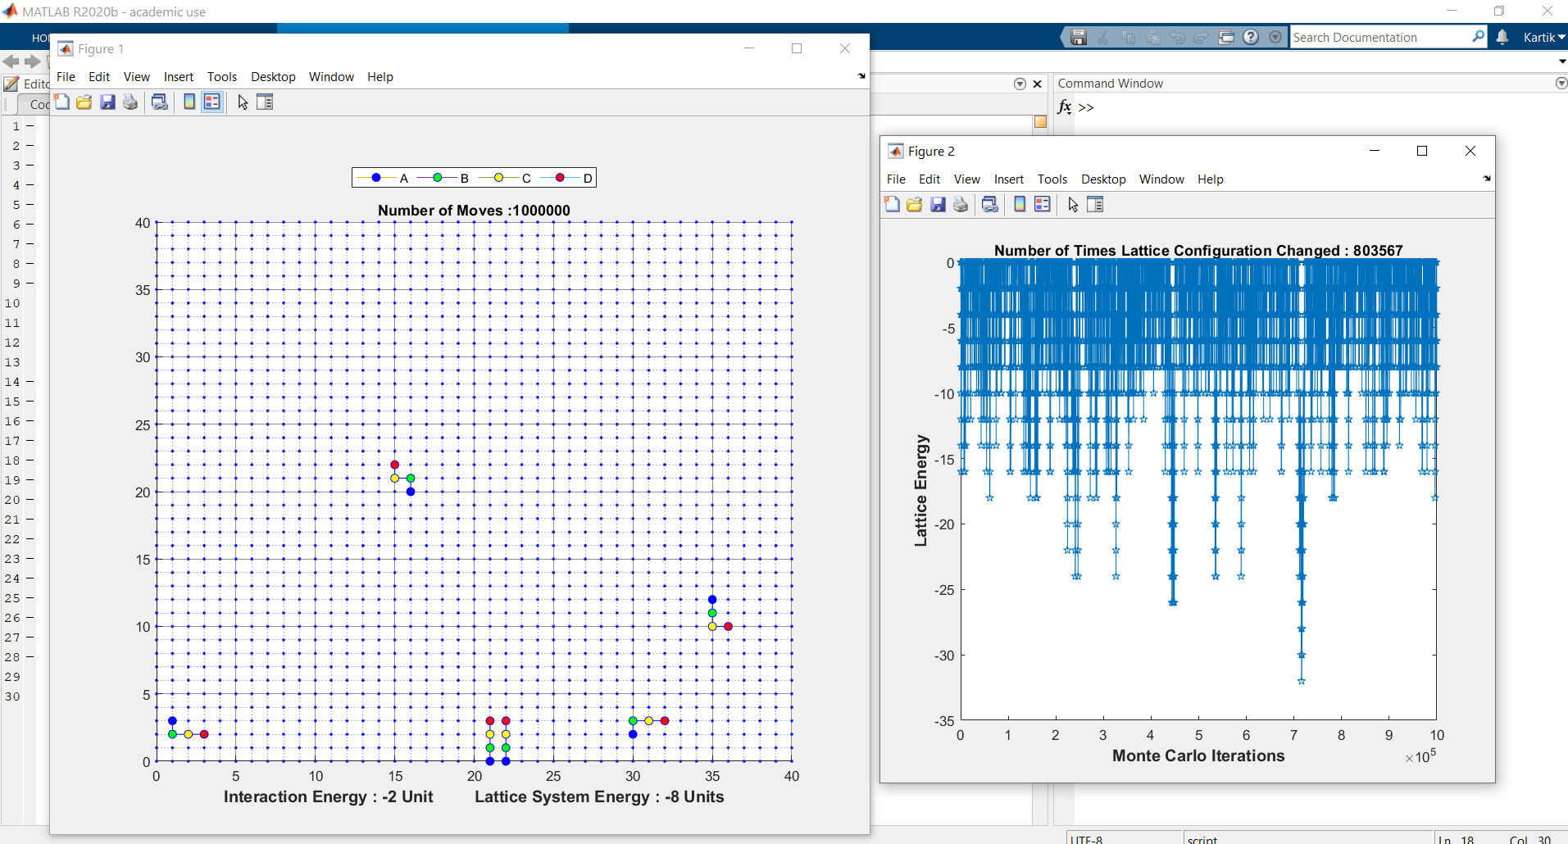

The Residues/Beads mostly stay in system stay in a disorganised form at low Interaction Energy.

For Interaction Energy = -3, Iteration = 1

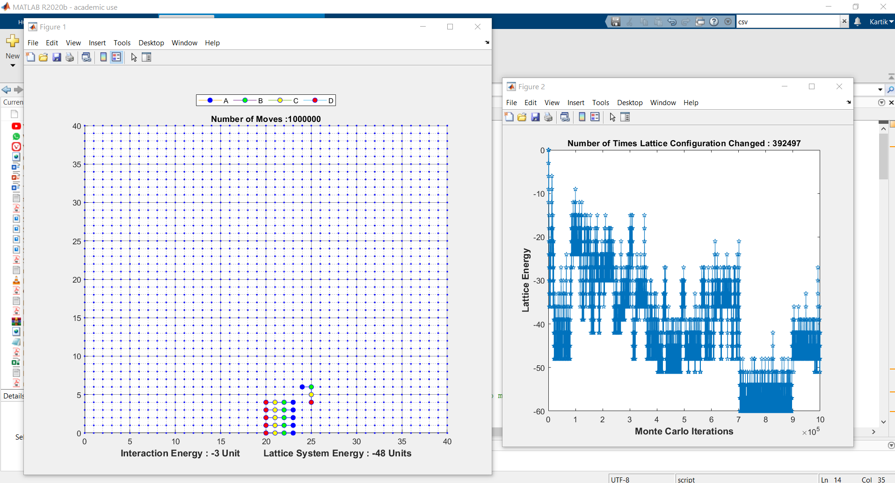

Iteration = 2

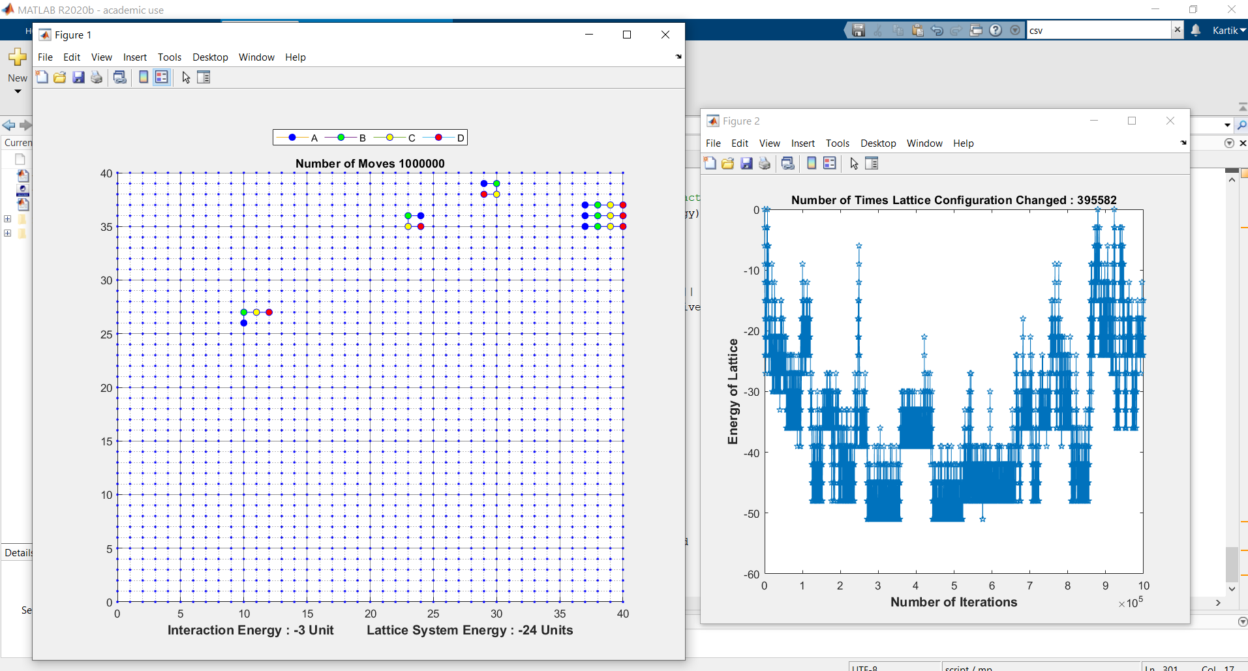

For Interaction Energy = -5, Iteration = 1

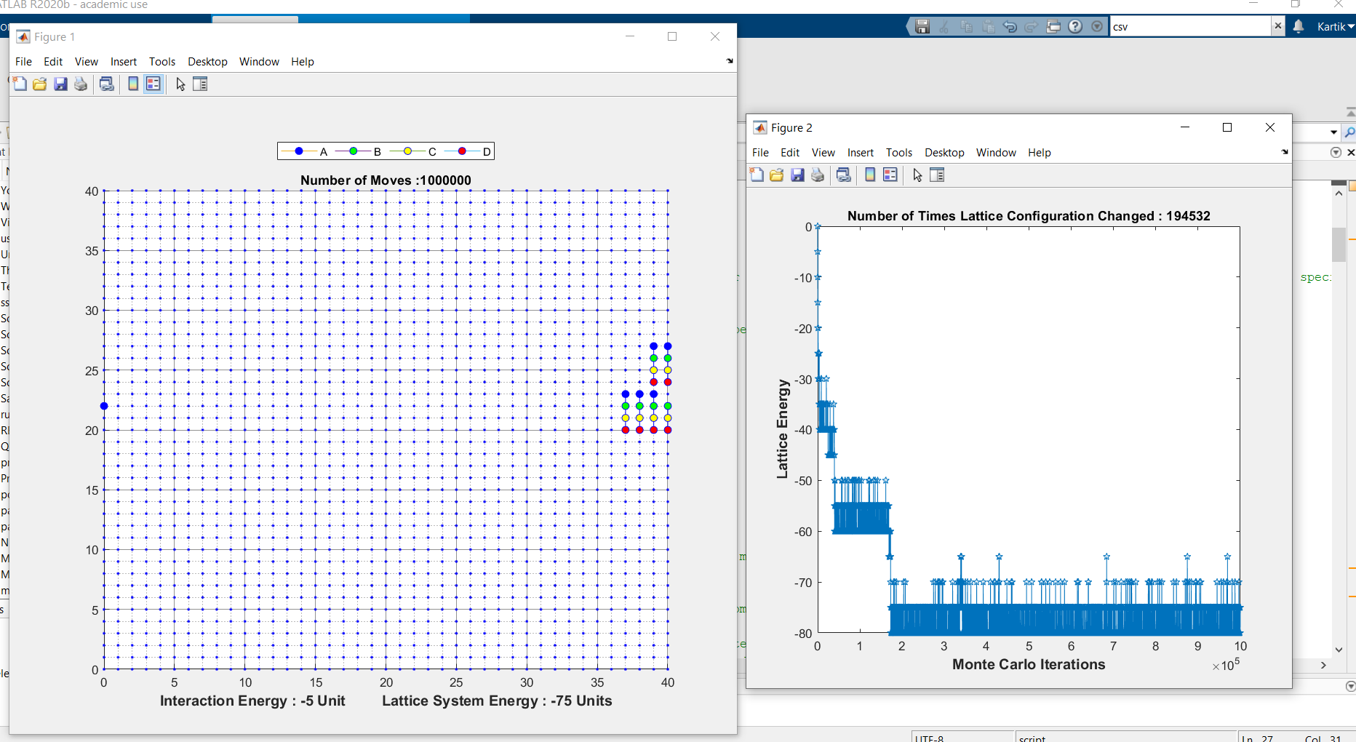

Iteration = 2

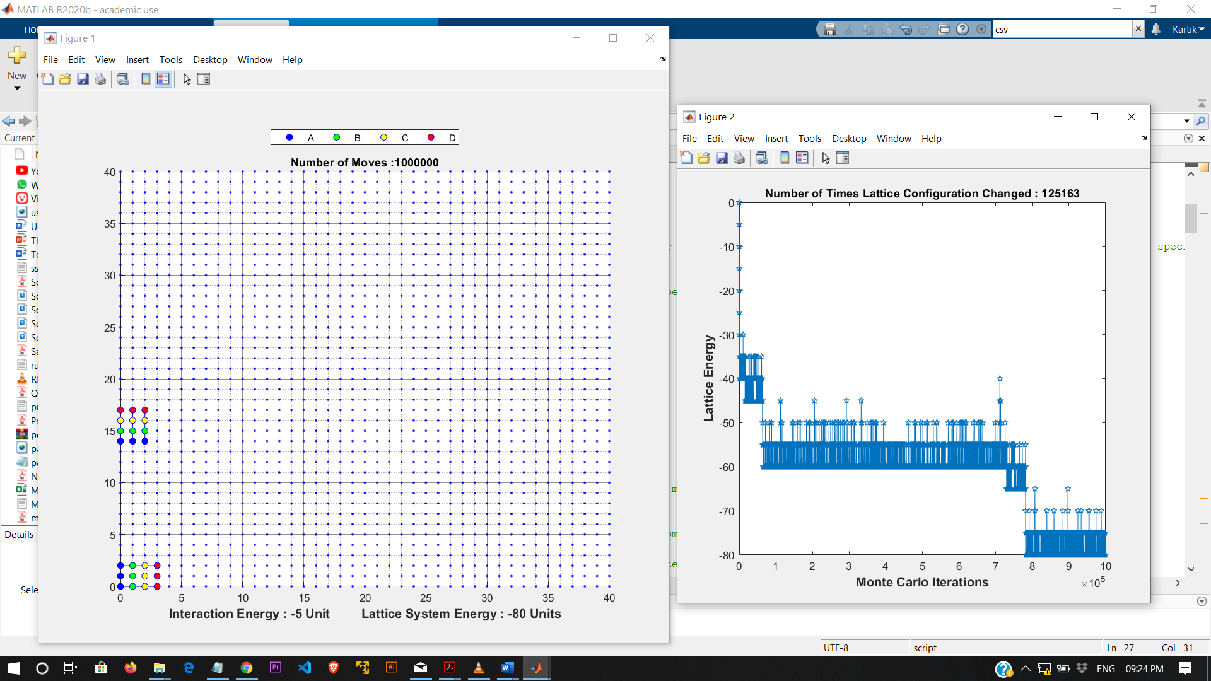

**For Interaction Energy = -1, -2, -3, -5 unit for part a), we observe**:

When Interaction Energy is low, the polymers stay scattered and do not fold together or make cluster as they break off easily and folded structure is not stable and vice versa. As per Energy vs Iteration graph, we can say that Interaction Energy increases the ease of protein folding.

Assemblies observed for different Interaction Energies in part a) are:

For IE = -1, we observe that polymers stay scattered and do not cluster.

For IE = -2, the polymers stay scattered throughout the lattice in which rarely a folded pair of polymer forms.

For IE = -3, cluster of 3 or 4 polymers is seen together with Residue/Bead A is in a linear direction with Residue A of other polymers in cluster. Similar pattern for other Residues.

For IE= -5, we observe mostly a cluster of all 6 polymers or pair of 3-3/4-2 clusters of polymers are formed in the lattice after 106 moves. Also, The Residue/Bead A is in a linear direction with Residue A of other polymers in cluster. Similar pattern for other Residues in the cluster (or Assembly) of polymers

**PART B :** For Part B, Any Residue/Bead can Interact with any other bead of different polymers.

When IE = -1, Iteration = 1 (for part b)

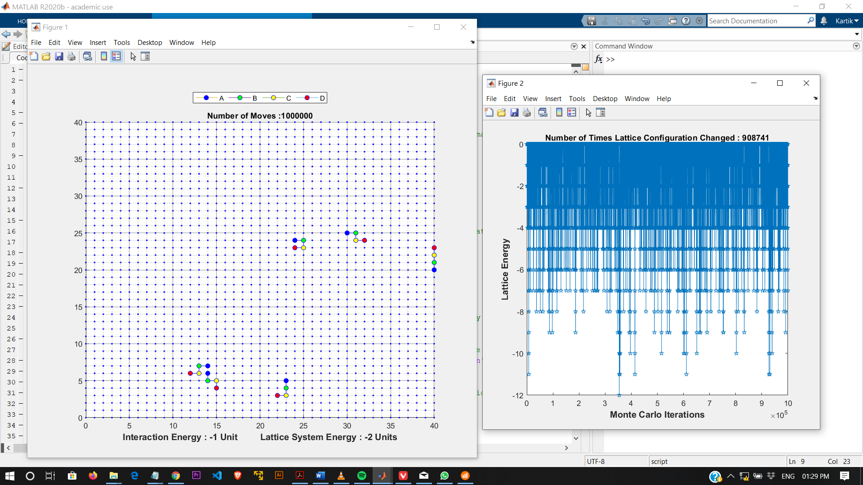

Iteration = 2:

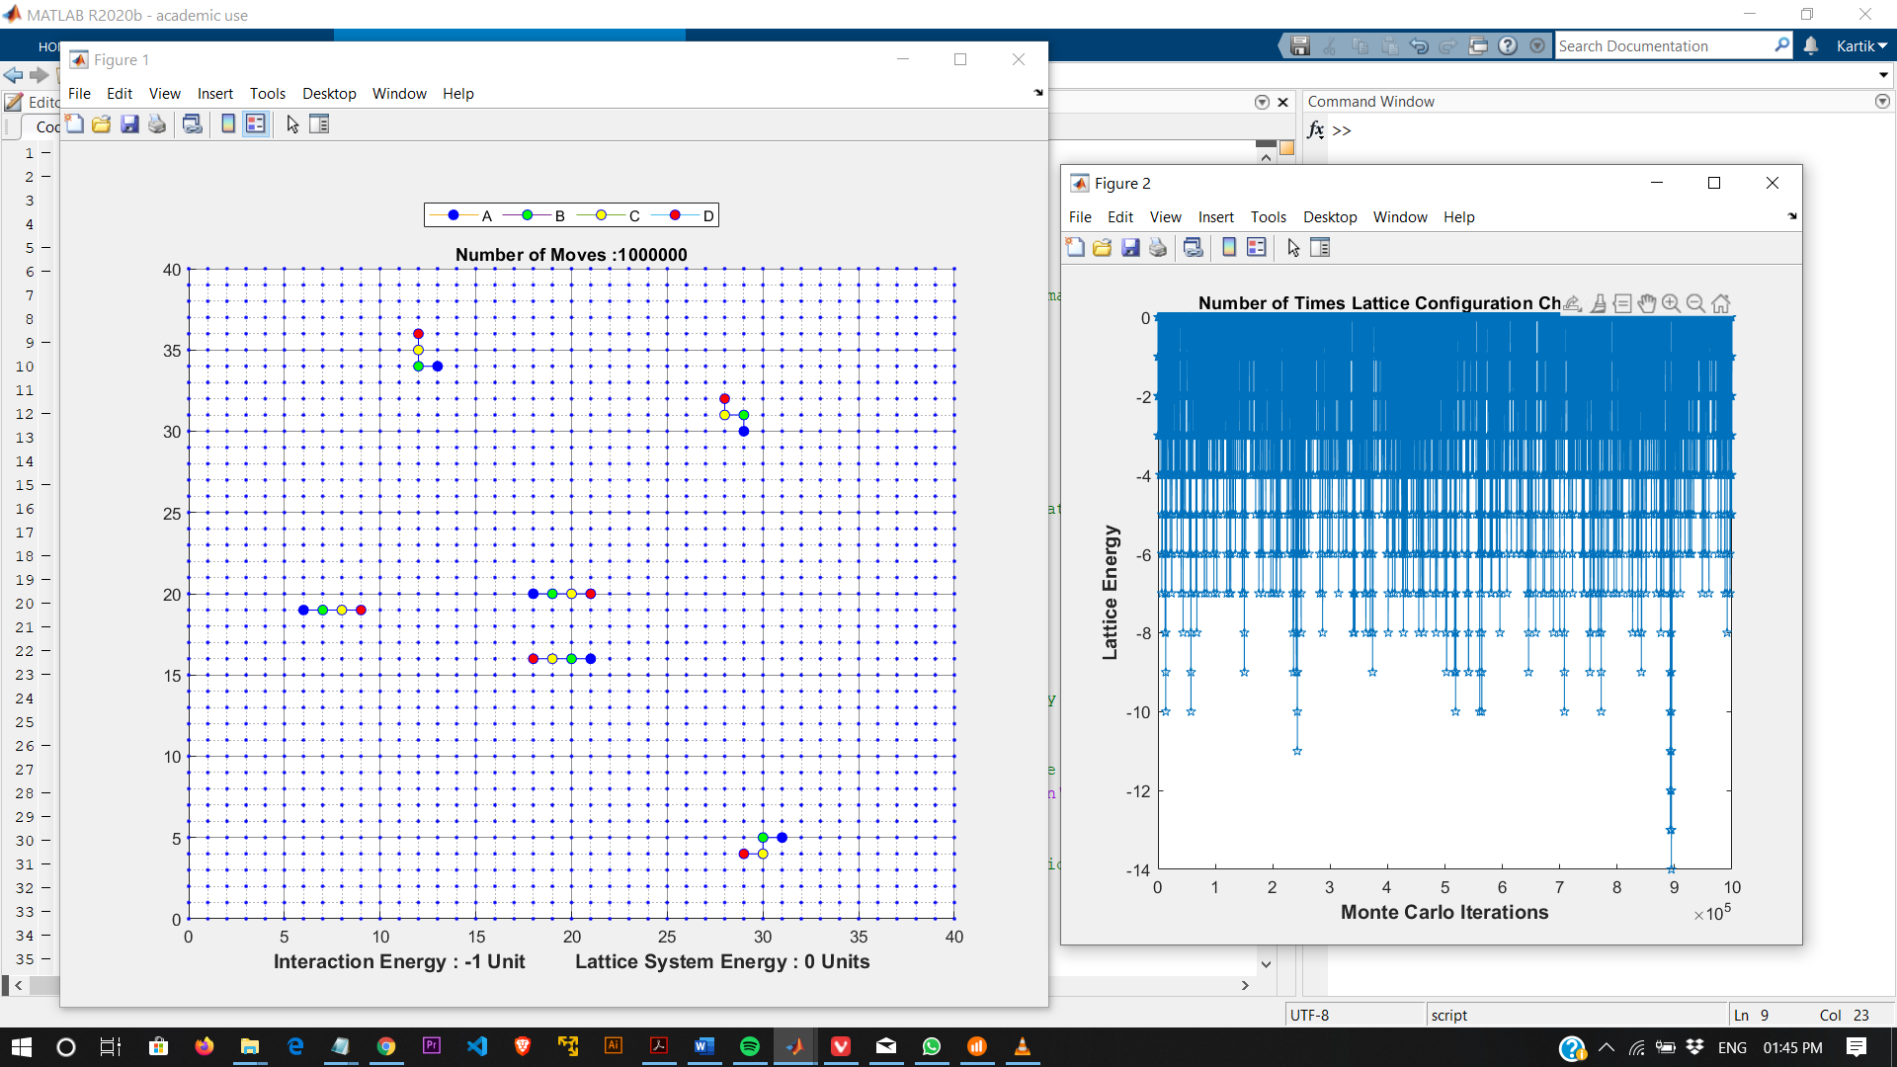

When IE = - 2, Iteration = 1:

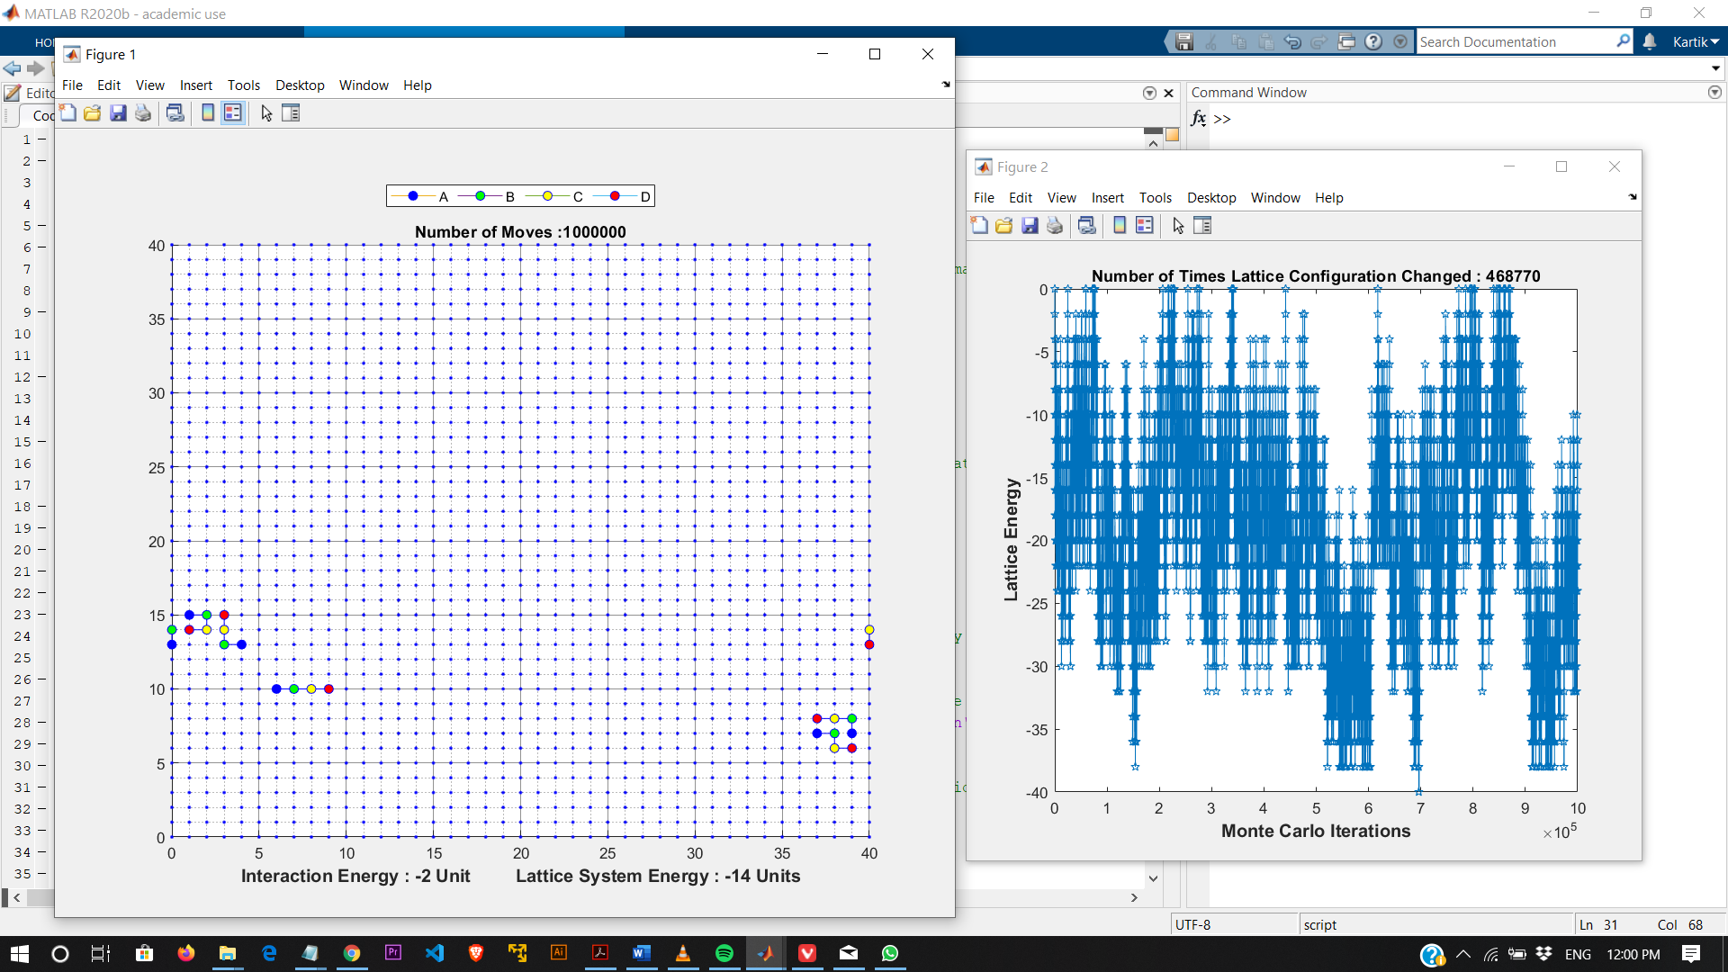

Iteration = 2:

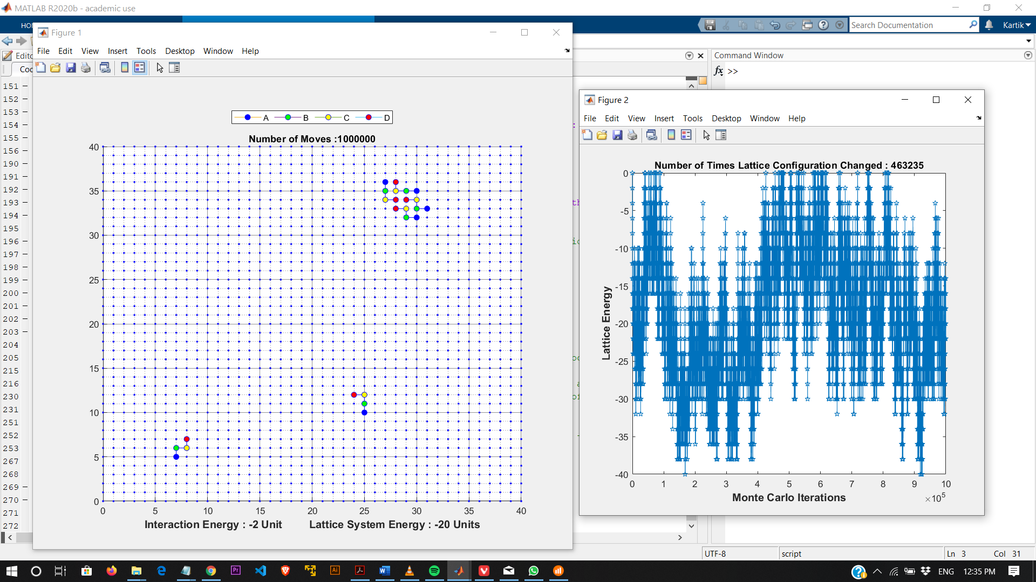

When IE = -3, Iteration = 1:

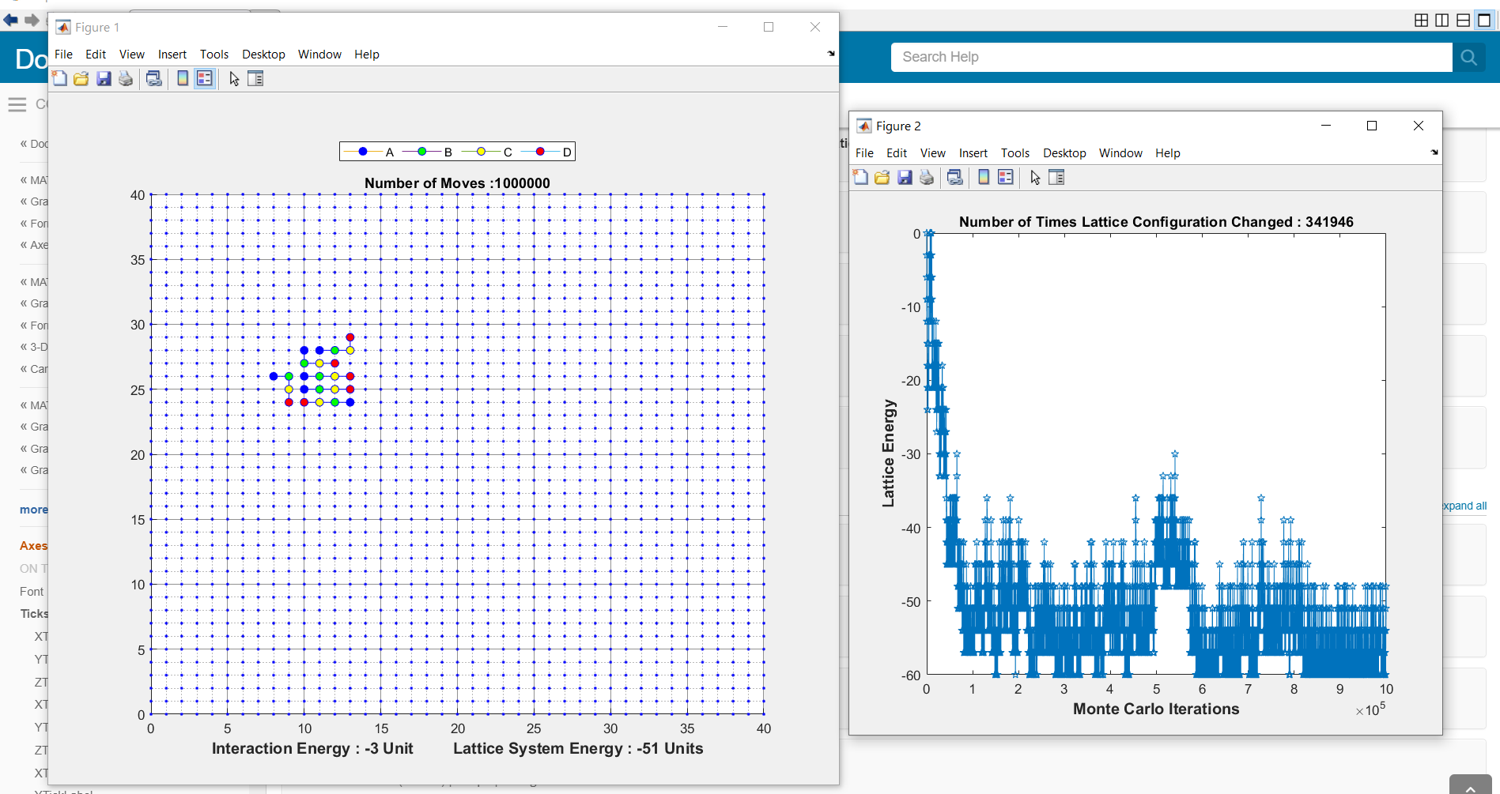  
Iteration = 2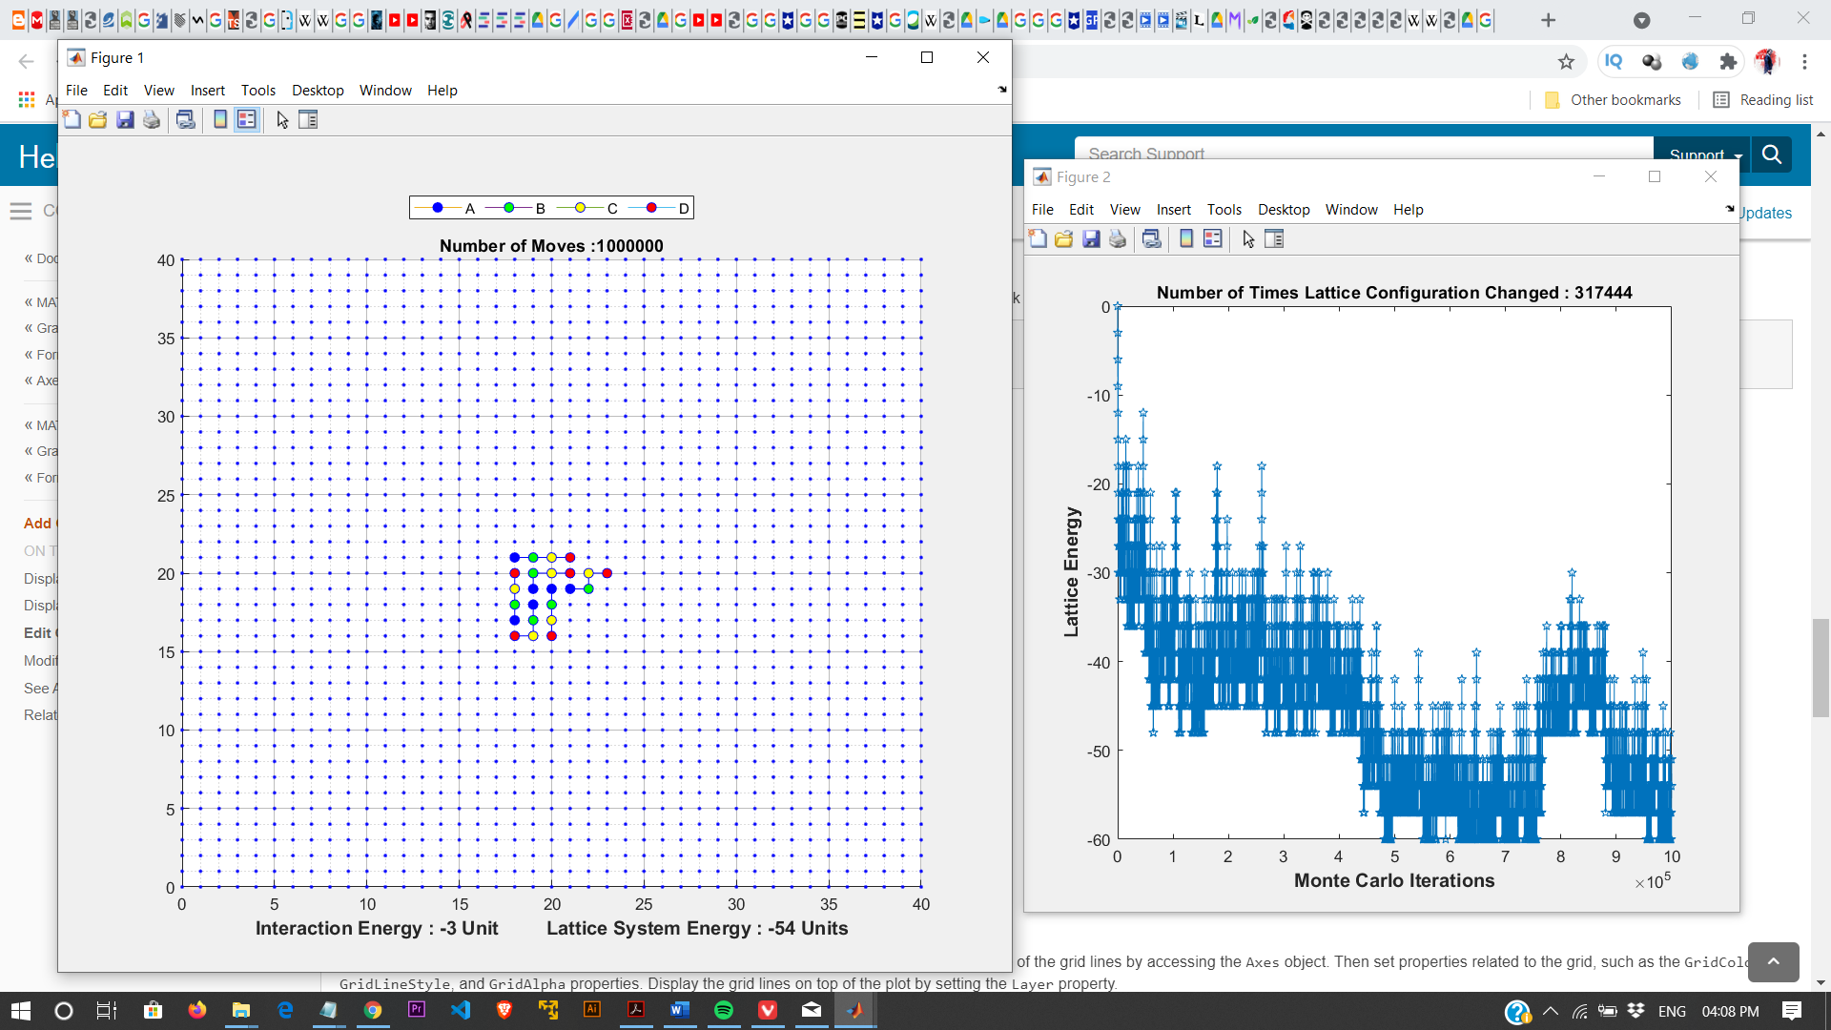

When IE = -5, Iteration = 1:

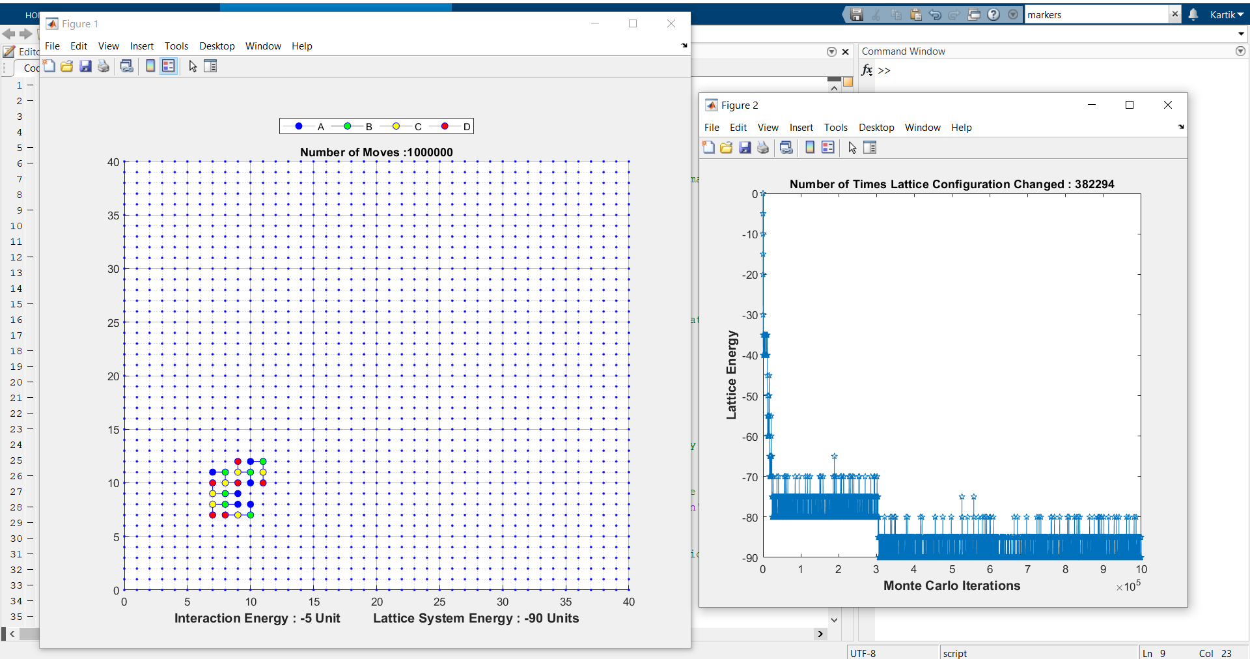

Iteration = 2

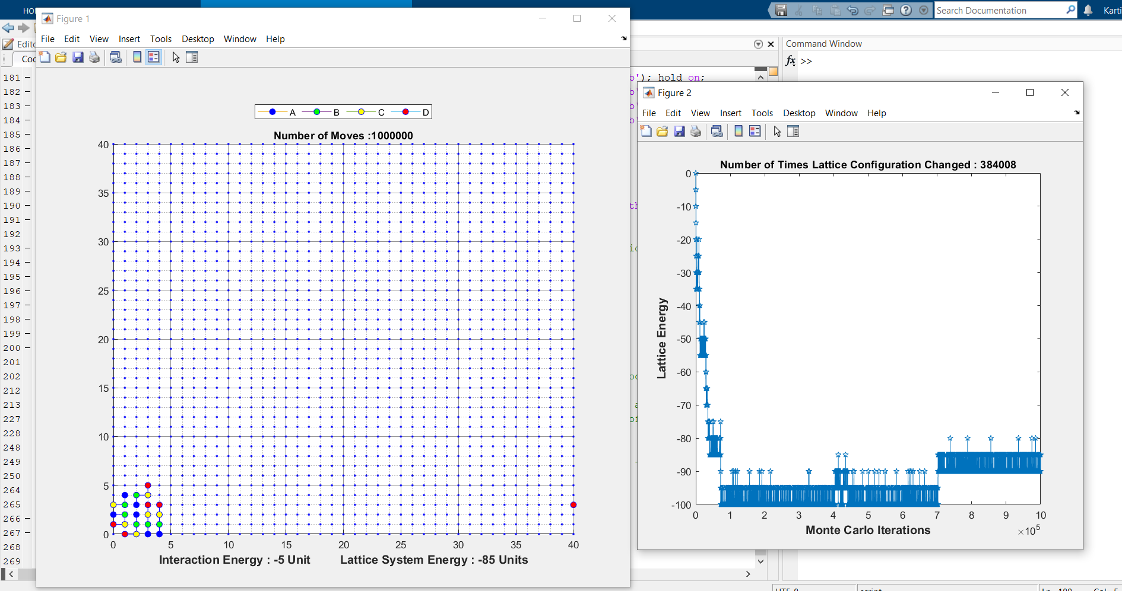

**For Interaction Energy = -1, -2, -3, -5 unit for part b), we observe**:

Assemblies observed for different Interaction Energies in part b) are:

For IE = -1, we observe that polymers stay scattered and do not cluster. Sometimes a pair of 2 polymer is seen but rarely.

For IE = -2, the polymers stay scattered throughout the lattice in which most of the times, a pair or a cluster of 2-3 polymers is observed to form more frequently than cases of part a) and part c).

For IE = -3, a cluster of 3 or 4 or 5 polymers is seen together irrespective of the residue type as each residue interacts with each residue of other polymers of same cluster.

For IE= -5, we observe mostly a cluster of all 6 polymers or pair of 3-3/4-2 clusters of polymers are formed in the lattice after 106 moves. Also, the polymers within the cluster are randomly located as if they are just trying to fit in the cluster with other polymers.

It is as if IE = -3, -5 show similar structure and IE<= -3 show cluster of all 6 polymers most of the time.

**PART C :** In part C, Residue(or say bead)A of one polymer can interact with residue A of a different polymer. Similar for Residue B but Residue C and D do not interact with any residue in every condition.

For IE = -1, Iteration = 1(Structure similar to given below occurs more frequent in IE = -1 case)

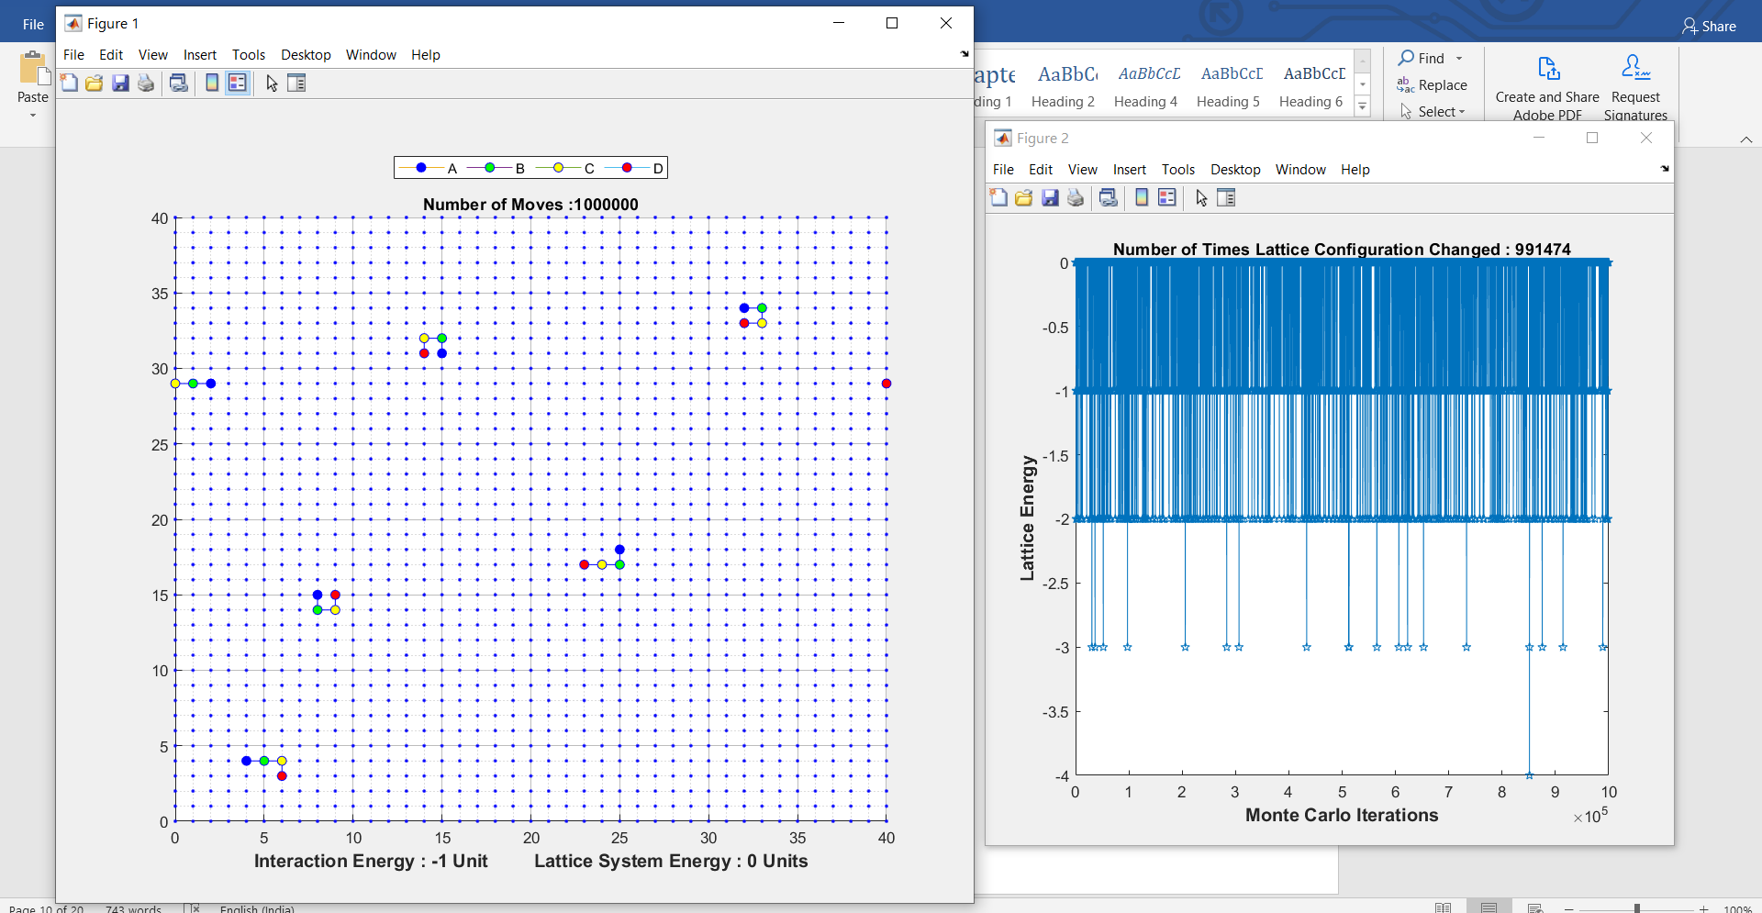

Iteration = 2:

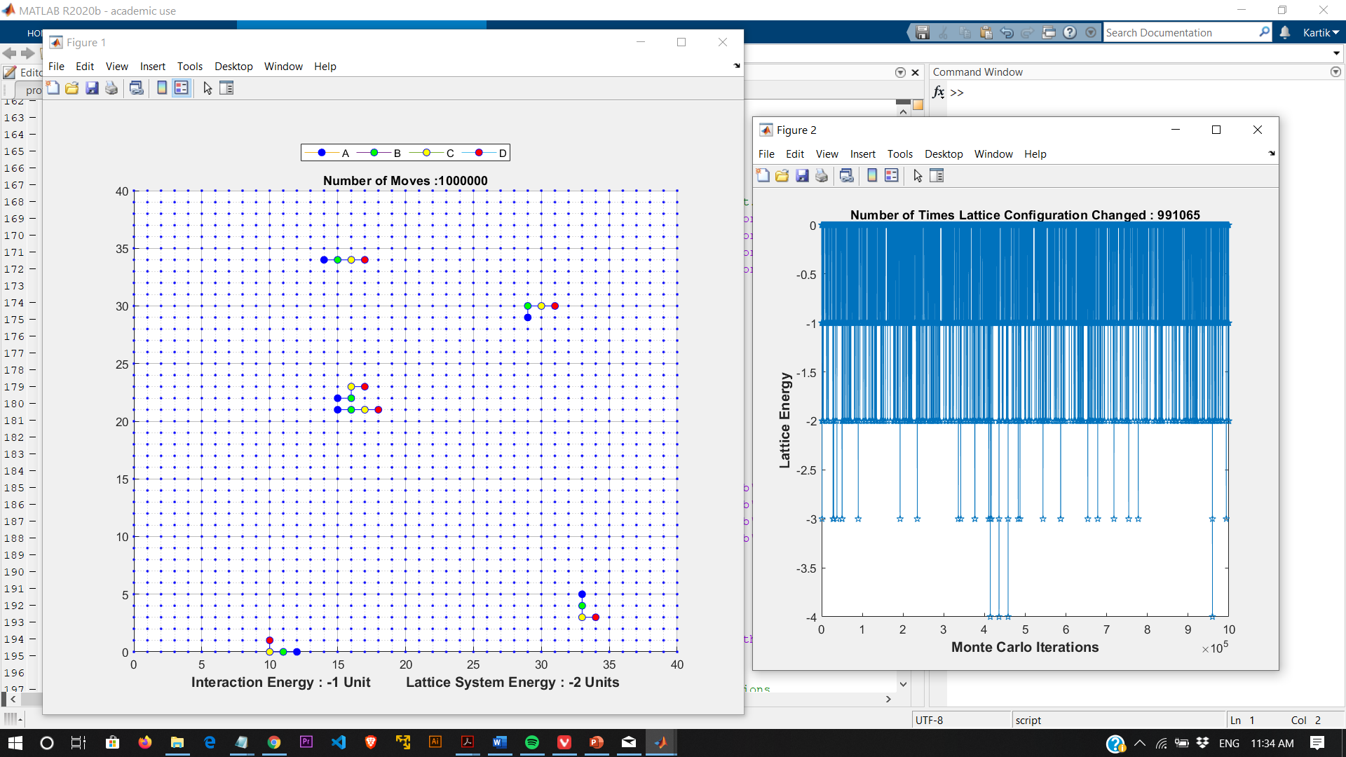

For IE = - 2, Iteration = 1:

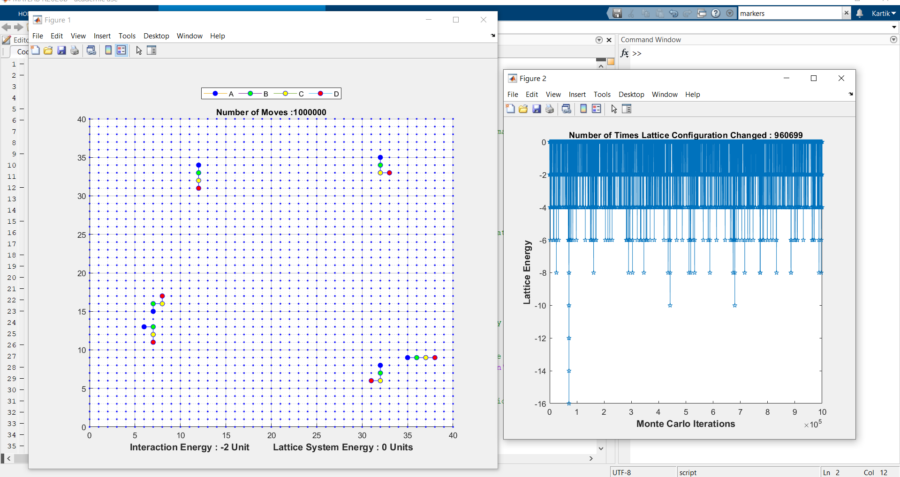

Iteration = 2:

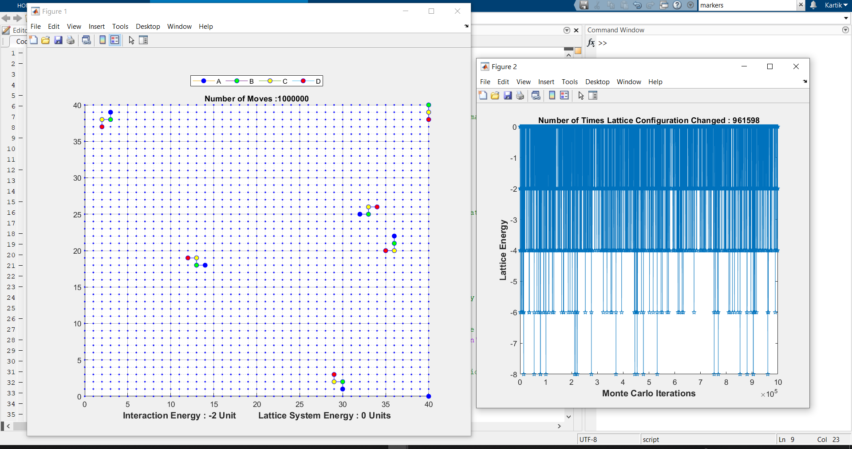

For IE = -3, Iteration = 1:

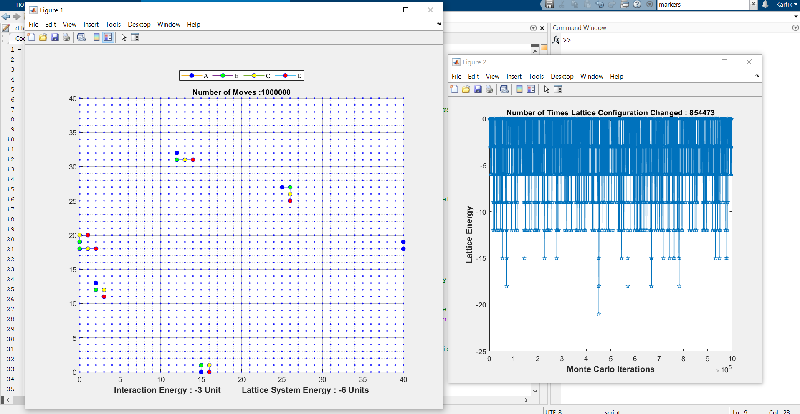

Iteration = 2:

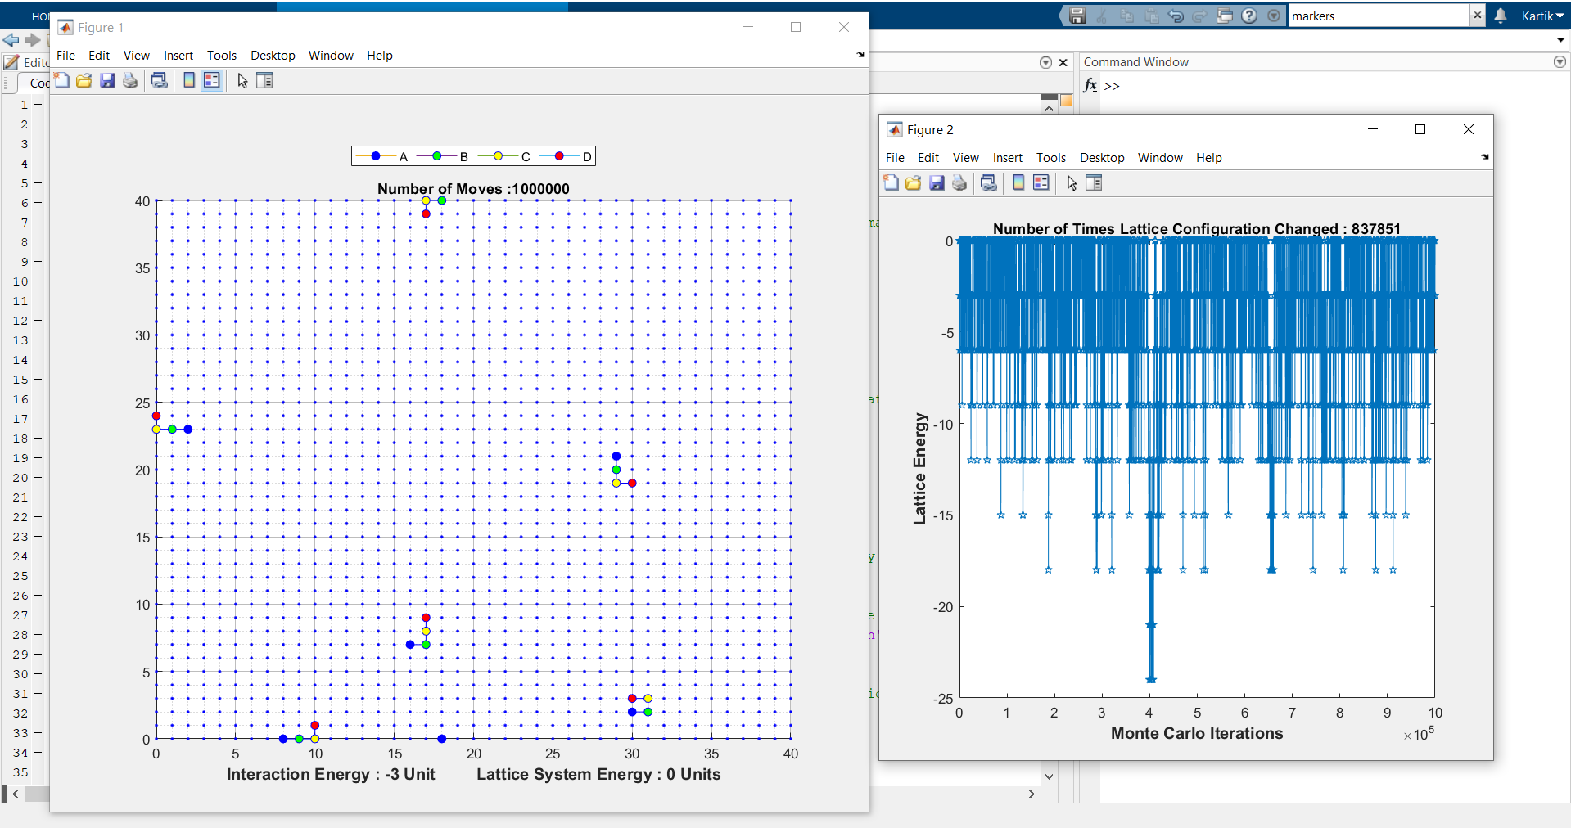

Iteration = 3:

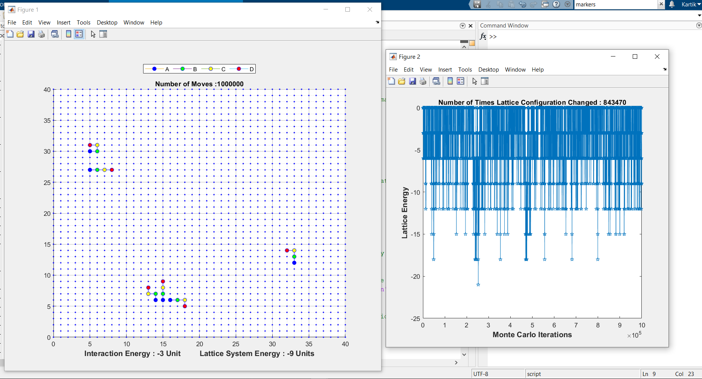

For IE = -5, Iteration = 1, we have:

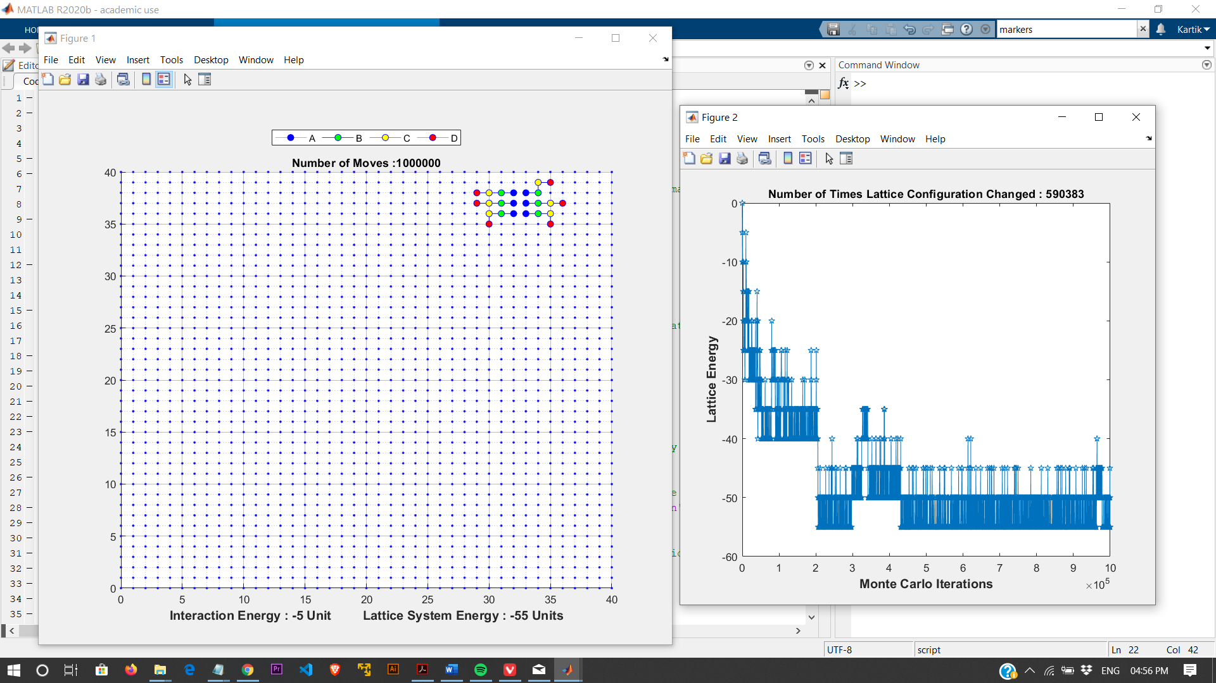

Iteration = 2:

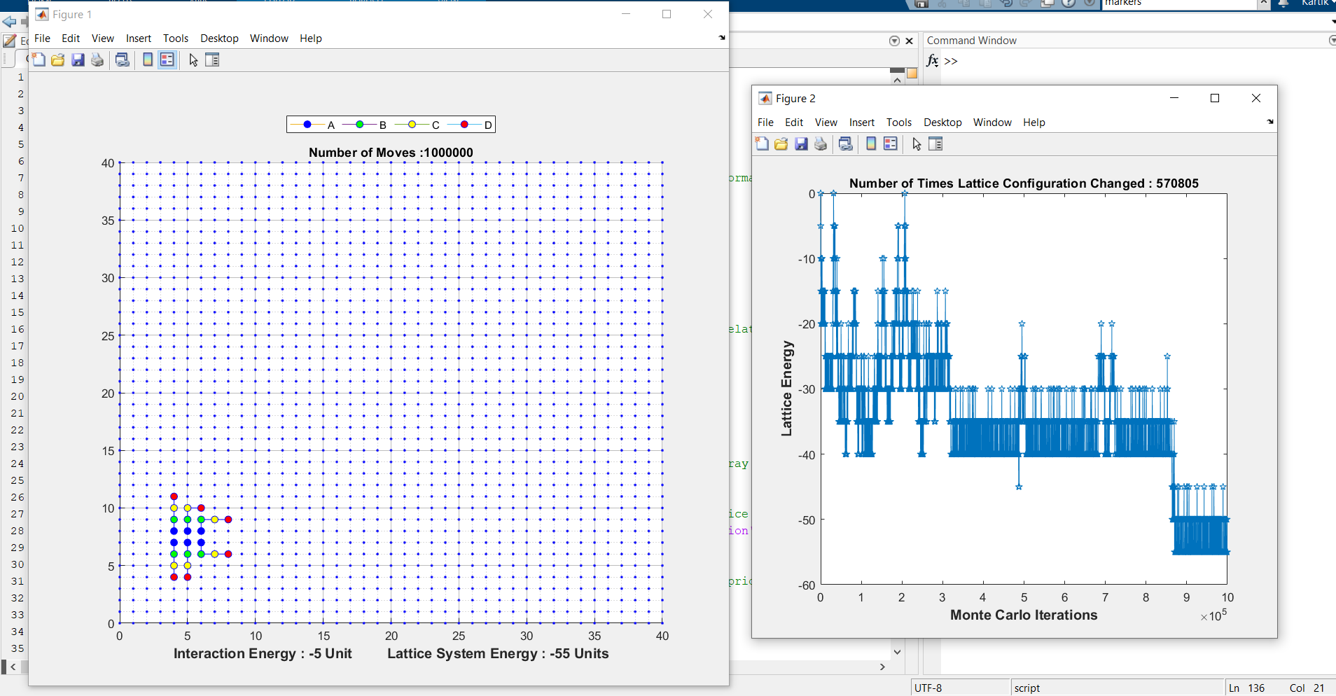

**For Interaction Energy = -1, -2, -3, -5 unit for part C, we observe**:

Assemblies observed for different Interaction Energies in part C) are:

For IE = -1, we observe that polymers stay scattered and do not cluster as seen in other parts. A pair of two beads together is rarely observed. (Rarer than observed in case of IE = -2)

For IE = -2, the polymers stay scattered throughout the lattice in which rarely a folded pair of polymer forms. Only the Residue A and Residue seems to stay connected in the interaction pair. It seems similar to case of IE = -1.

For IE = -3, cluster of 2 or 3 polymers is seen together with Residue A seems to be connected to Residue A of any other polymer present in same cluster. Similar pattern is seen for Residue B but not for Residue C and Residue D. Also, sometimes all of the stay scattered similar to case of IE = -1.

For IE= -5, we observe mostly a cluster of all 6 polymers IS formed in the lattice after 106 moves. Here, Residue A seems to be connected to Residue A of any other polymer present in same cluster. Similar pattern is seen for Residue B but not for Residue C and Residue D. They seem to form a shape of spider as shown in iterations 1,2 of IE = -5.

In all the parts :

We observe that on increasing the interaction energy the protein folds at faster rate and folds in a more specific manner. On increasing interaction energy the system rejects the free movement easily for sake of folding and does not break its interaction with other residues easily. The probability of the residue of the protein to break interaction with another residue decreases as shown by Energy vs Monte Carlo Iteration graph as it becomes more and more stable.

Also, It is easy for proteins to break their folded structure on low Interaction Energy.